OWNER’S MANUAL
PLEASE SAVE THIS MANUAL FOR FUTURE REFERENCE

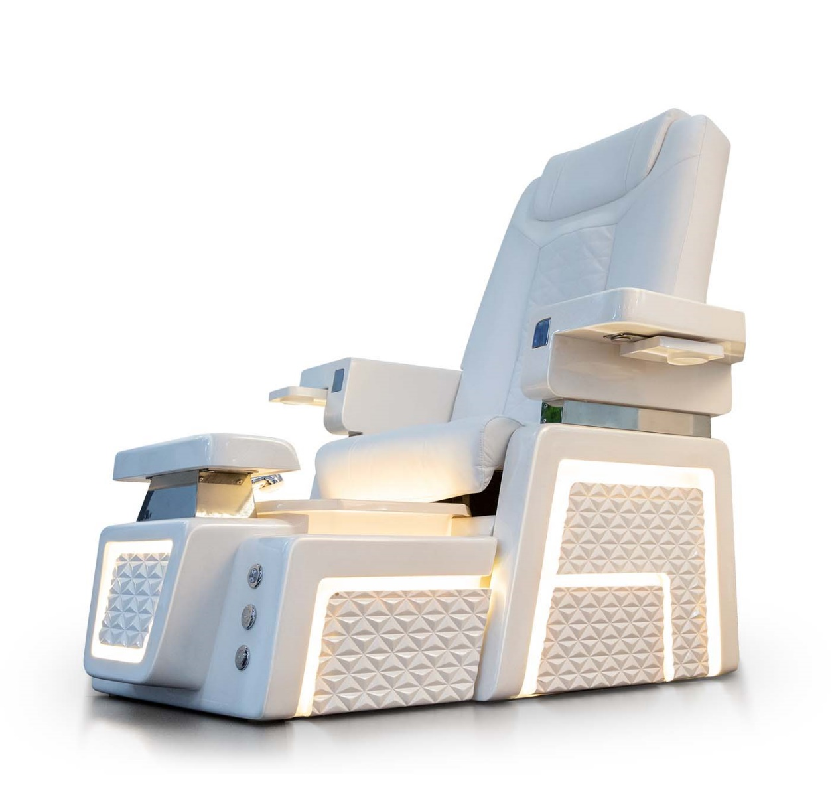

PRESIDENT CHAIR

MODEL: WYATT PEDICURE CHAIR
TABLE OF CONTENTS

Safety & Precaution 03

Specification 08

Identify Your Foot Spa 09

Foot-spa Clearance 10

Installations 11

Operation & Use 18

Maintenance & Use 20

Warranty & Service 22

UL Certificate 24

Warranty Registration Form 25

SAFETY & PRECAUTION

DANGER: Risk of Electric Shock. Connect only to a circuit protected by a ground fault circuit interrupted

GROUNDING IS REQUIRED. The unit should be installed by a qualified service representative and grounded.

Install to permit access for servicing.

CAUTION: Risk of electric shock. Disconnect electric power before servicing.

WARNING: Risk of accidental injury or drowning; children should not use hydro massage bathtub with- out adult supervision.

WARNING: Risk of accidental injury or drowning; do not use hydro massage bathtub unless all suction guards are installed to prevent body and hair entrapment.

WARNING: To avoid injury, exercise care when entering or exiting the hydro massage bathtub.

WARNING: Risk of accidental injury or drowning, do not use drugs or alcohol before or during the use of a hydro massage bathtub equipped with heater to avoid unconsciousness and possible drowning

WARNING: Risk of fetal injury; pregnant or possibly pregnant women should consult a physician before using a hydro massage bathtub equipped with heater.

WARNING: Risk of hyperthermia and possible drowning; do not use a hydro massage bathtub equipped with heater immediately following a strenuous exercise

WARNING: Risk of electric shock; do not permit electric appliances (such as a hair dryer, lamp, telephone, radio, or television) within 1.SM (5 feet) of this hydro massage bathtub.

CAUTION: Test the ground fault circuit interrupted protecting this appliance periodically in accordance with the manufacturer’s instructions

SAFETY & PRECAUTION

WARNING: Risk of hyperthermia and possible drowning; water temperature inexcessof38°C(100.4°F) may be injurious to your health. Check and adjust water temperature before use.

WARNING: Risk of hyperthermia; people using medications and/or having an adverse medical history should consult a physician before using a hydro massage bathtub equipped with heater.

WARNING: It is very important that you carefully follow the basin cleaning procedures on page 17 to ensure that the spa is sanitized after each use. T-SPA is not liable for any infections or disease that may result from improper cleaning or failure to adhere to sanitation requirements.

This pedicure spa unit should only be operated in a room temperature between 40°F (4°C) and 100°F (38°C). DO NOT use unit outdoors or in excessively humid or dusty environments.

DO NOT use unit where aerosol (spray) products are being used or oxygen is being administered. DO NOT operate unit if it has been damaged.

Always connect this unit to a properly grounded electrical outlet. This unit is designed only to operate on a standard 110 Volt 60Hz current. Exceeding this standard may cause injury and/or serious bodily harm and/or damage to property.

DO NOT use this unit if noise above normal sound is heard.

To reduce the risk of burns, fires, and electrical shock, never leave this unit unattended if plugged in and always unplug when not in use for an extended period, before installation, cleaning, or removal of parts. Keep the power cord away from heated surfaces.

DO NOT operate unit if the power cord or plug has been damaged.

If this unit is operating abnormally or malfunctioning, immediately turn off the power and disconnect the power cord from the outlet; do not operate unit if it is not working properly.

SAFETY & PRECAUTION

In the event of a power failure, always turn the power switch to its OFF position. When not in use always turn the power switch OFF position.

To disconnect unit, turn all controls to OFF position and remove power cord from the outlet. Keep all electrical devices away from this unit.

This unit only has a weight capacity of 200pounds (90.72 kg). Enter and exit the unit slowly and carefully.

Never drop or insert any object into any opening of the unit.

Close supervision is necessary when this unit is used by, on or near children, invalids, and disabled persons. Do not stand or allow anyone to stand in the spa basin.

Please be aware that a spa basin filled with water is a potential drowning hazard.

Check the water temperature before each use; water temperature should not exceed 105°F (41°C) and water temperature in heater should not exceed 150°F (65°C).

Disinfect the spa basin and jets, after each use with an approved cleaner.

Do not massage any area of the body that is swollen, inflamed, or covered with skin eruptions. Before operating the massage chair, make sure the chair arms are down.

If there is severe discomfort during the massage, discontinue use and consult a physician. Do not use the massage chair for more than 15 minutes at one time.

Do not put hands or fingers near massage mechanism or rollers while the chair is operating; touching the mechanism can result in injury from the rollers squeezing together.

Keep the massage chair and its air openings clean and free of hair and dust; never operate the massage chair if the air openings are blocked.

Misuse or failure to properly clean pedicure spa unit may result in serious health issues, bodily injury, and/or death.

SAFETY & PRECAUTION

HEALTH RISK WARNING:

Use of the pedicure spa unit should be pleasant and comfortable; if there is any pain or discomfort, stop use of the pedicure spa immediately.

A physician should be consulted before use of the massage chair by anyone with the following conditions: Malignant tumor, heart disease, pregnancy, Conditions requiring rest, and back disease or trouble from an injury or accident.

A physician should be consulted before use of the spa basin and jets, by anyone with diabetes, swelling, fracture, or persistent pain.

Anyone with inflamed legs or feet, open wounds, or fungal infections should not use the spa basin and jets.
Misuse or failure to properly clean pedicure spa unit may result in serious health issues, bodily injury, and/or death.

WARNING - GROUNDING INSTRUCTIONS AND METHODS:

This unit must be grounded. If it should malfunction or break down, grounding provides a path of least resistance for electrical current to reduce the risk of electric shock. All outlets connected to epicures as must include a GFCI device (Ground Fault Circuit Interrupter). This will reduce the risk of electric shock.

This unit is for use on a standard 110 Volt 60Hz current.

This unit is equipped with a cord having an equipment grounding conductor and a grounding plug. The plug must be plugged into an appropriate outlet that is properly installed and grounded in accordance with all local codes and ordinances.

If you are in doubt as to whether this unit is properly grounded, check with a qualified electrician or serviceman. Fatal electric shock and fire could occur with improper connection of the equipment- grounding conductor. Do not modify the plug provided with the product for any reason; if it will not fit the outlet, have a proper outlet installed by a qualified electrician.

SAFETY & PRECAUTION

WARNING: THERMAL RESETTING PROTECTION DEVICE

The massage chair is equipped with a thermal resetting protection device. This is a safety feature to protect it from overheating. If the chair should suddenly stop and will not start, turn the main power switch off, and do not operate the chair for at least 30 minutes. Failure to turn the chair off may result in the chair starting unexpectedly when the device cools.

SPECIFICATION
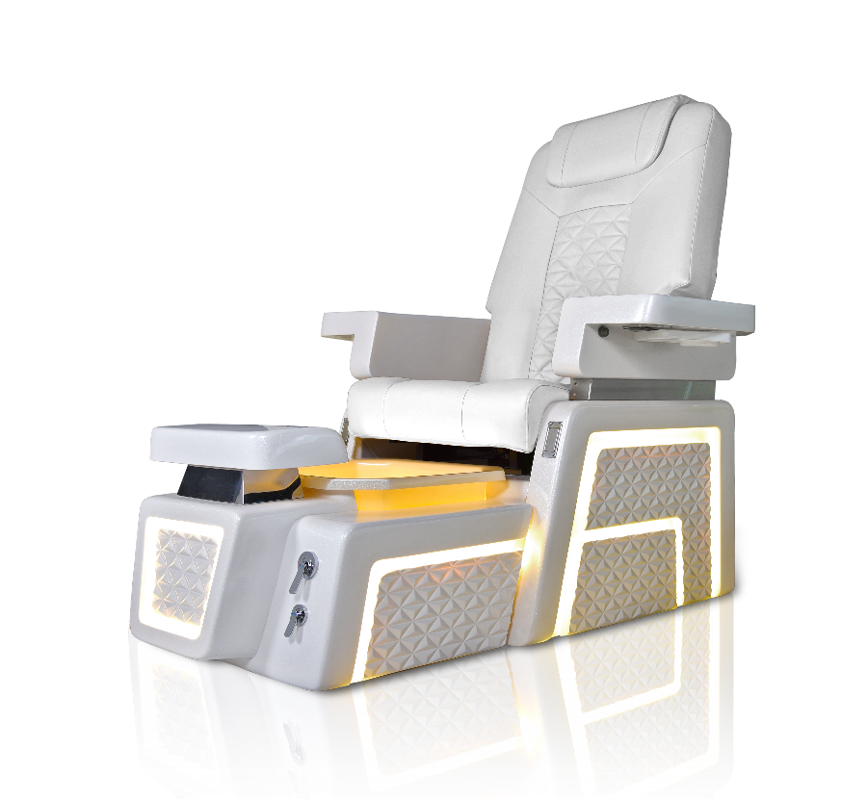

MODEL: PRESIDENT
Dimension (Shipping) | Pedicure Spa  Massage Chair  Stool | 55L x 28W x 20H  44L x 31W x 24H  21L x 27W x 17H
Weight (Shipping) | Pedicure Spa  Massage Chair  Stool | 150 lbs.  120 lbs.  17 lbs.
Capacity | 200 lbs. | 4.5 US Gal
Switch |  | On/Off Air Activated Switch
Power Source | Dedicated 15A Wall Outlet.  Require Pipe-less whirlpool motor | 120V, 0.4A, 60Hz
Water Pump Power Source | Discharge Pump motor (optional) | 115V, 3.2A, 60Hz
Massage System |  | 120V, 60Hz
Plumbing Source | Hot Water  Cold Water  Drain | 3/8 inches  3/8 inches  1-1/4 inches – 1-1/2 inches
Warranty | Unit  Optional Item | 1 year  120 Days

IDENTIFY YOUR FOOT-SPA

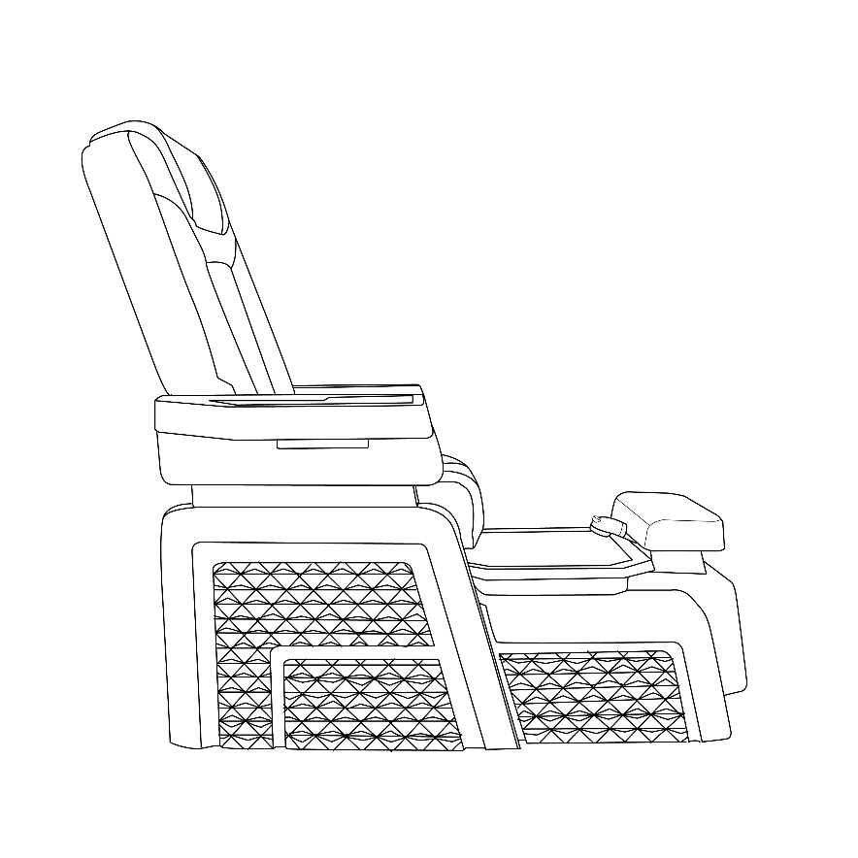
SEAT OPERATION
Reclining 135º

Armrest can be raised up/down

Chair Sliding

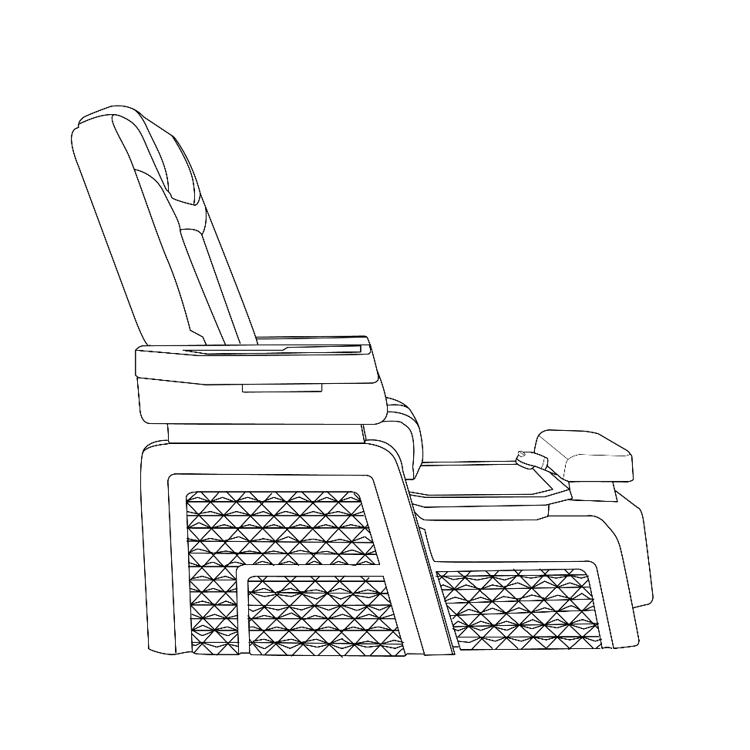

SPA DIMENSION

Height 63”

Rear Width 30”
Front Width 25”
Length 54”

FOOT-SPA CLEARANCE
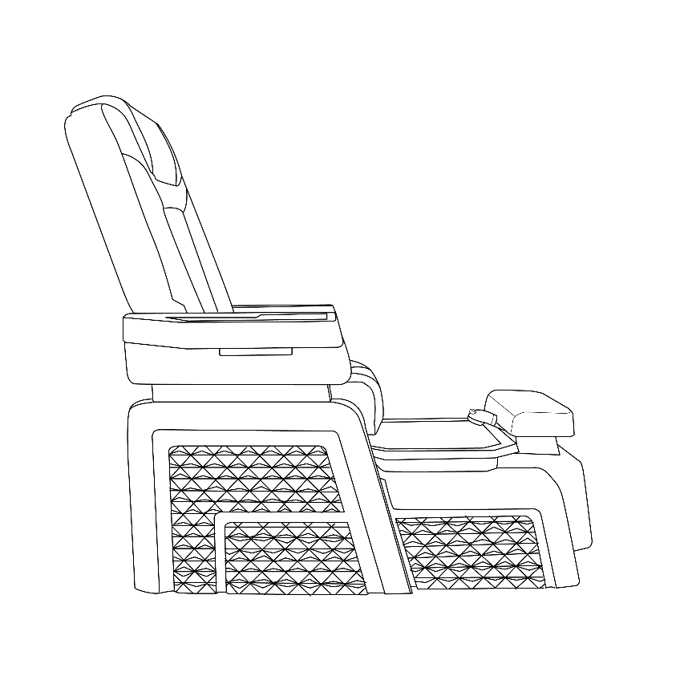
WALL CLEARANCE

22” between
edge of spa and wall

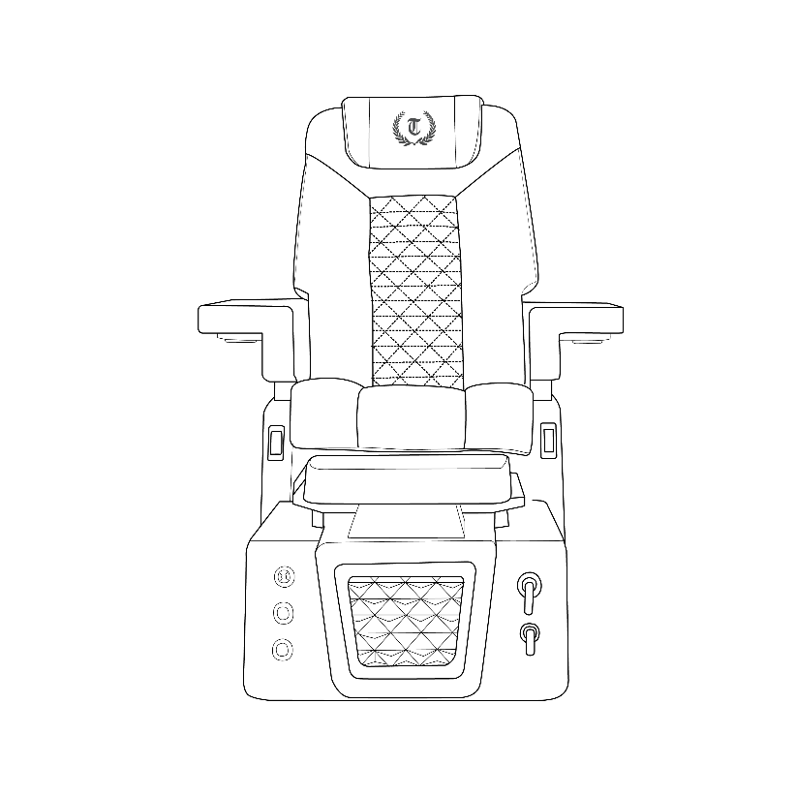
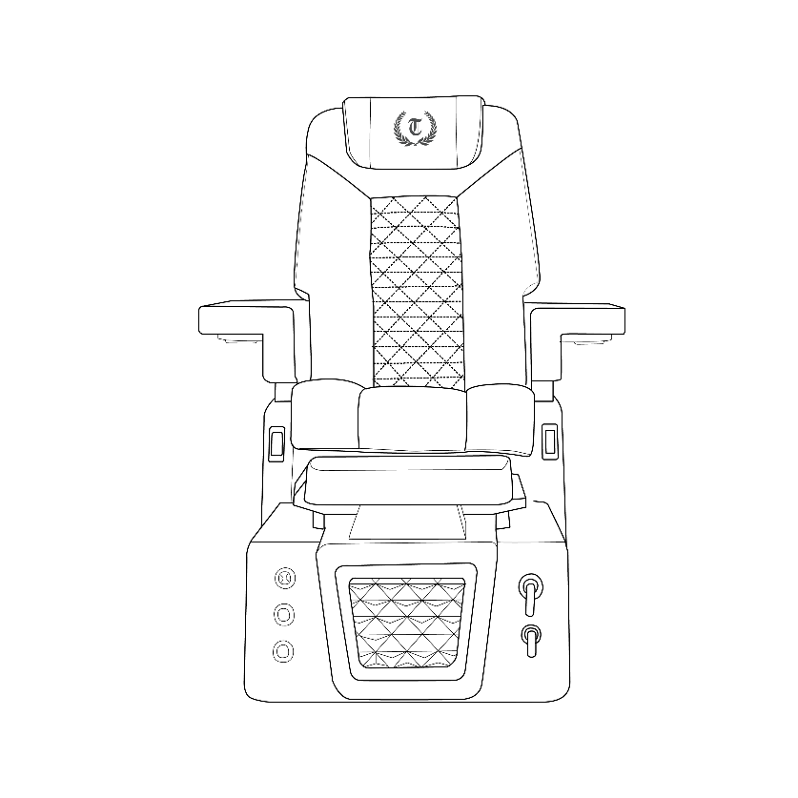
TYPICAL FOOT-SPA
2”-3” minimum between
manicure trays

50” between each spa

INSTALLATIONS

Align the seat with pre-drilled holes on the base then tightly secure with provided nuts and bolts.
Attach trays or remote stand to armrest with provided screws.

VERSION: PRESIDENT
MODEL: PRESIDENT PEDICURE CHAIR
INSTALLATIONS

When using electrical equipment, basic safety precautions must be followed to reduce the risk of fire, electrical shock, and injury to persons.
- Read and follow all instructions before using the equipment.
- Keep electrical cord out of heavy traffic area to avoid fire hazard. NEVER place electrical cord under the rug, or near a heat generating device.
- Always turn off the equipment before service.
- Do not drop or insert any object into any openings.
- Do not operate any equipment with damaged parts.
- Any other use not recommended by the manufacturer may cause electrical shock or injury to person.
- Never use it outdoor.
- Do not attempt to repair or adjust any electrical or mechanical

CLEANING INSTRUCTION

- Turn off the unit and wait until the motor fully stops.
- Hold whirlpool jet cover firmly and pull to separate from the round magnetic field.
- Turn hydro whirlpool jet cover to the left to open and pull out the impeller.
- Use Anti-Bacterial solution (EPA Registered) to clean all parts.
- After sanitizing all parts, place impeller back inside and close hydro whirlpool jet cover, turn right to lock the cover.
- Firmly hold the whirlpool jet cover and gently place it onto the round magnetic field. DO NOT release the hydro whirlpool jet cover until jet cover is on the round magnetic housing.

INSTALLATIONS

JET UNIT COMPONENTS
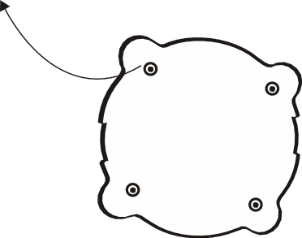
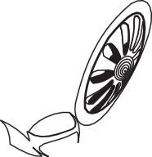
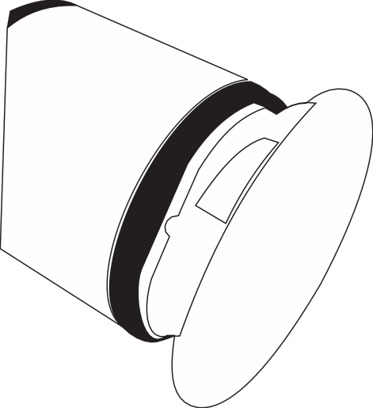
Magnetic Jet Base
Magnetic Impeller
Whirlpool Motor

Whirlpool Jet Cover

Bottom view of magnetic jet base

MAGNET JET FEATURE
- Hydro dual-massage jet stream.
- Magnetic whirlpool jet cover can be removed for quick cleaning and sanitizing.
- Built-in electronic sensor for pump control.
- AC Whirlpool motor (long life).
- Very low power consumption (27W).
- Manufactured in the U.S.A.

MAGNET JET SPECIFICATIONS

Model: MAGNA JET – 120 VAC, 60 Hz, 1.0 A

Pump: Hydro Dual-Massage Jet Flow

Mounting: Single 3.5”-diameter hole with auto tighten mounting screws (4)

INSTALLATIONS

PLUMBING CONNECTIONS

- A discharge pump system connected to an existing sink drain or floor drain can pump up to 7ft high but will increase draining time. Drain connections at the rear of the unit by ¾” fitting.
- Gravity drain uses a standard gravity drain. A Floor drain is recommended. P-Trap is not installed nor supplied. The Floor drain should already have a P-Trap and UPC codes. DO NOT allow double P-Trap in the system.
- Hot and Cold-water supply connections are located at the rear of the unit (½” fitting). Please be advised that the Hot and Cold-water supply lines are not fitted with optional backflow. Preventers unless ordered at initial sale.
- Have a qualified licensed electrician to install the wiring according to local codes. The Clean jets are 1/18 HP, 120V A.C., 0.55 AMP, 60 Hz. GFI protected circuit must be used to supply power to the unit. The roller back massage chair uses a 115V A.C. supply.
- Spa base should be anchored securely to the floor. The base may be anchored through the opening in the back of the base wherever access is convenient for the installer.
- Handheld sprayer. It has complied with applicable requirements of ASME A112.18.1-2005/CSA B125.1-05

FAILURE TO ANCHOR THE BASE MAY RESULT IN PERSONAL INJURY OR DAMAGE TO UNIT. DAMAGE AS A RESULT WILL VOID THE WARRANTY.

INSTALLATIONS
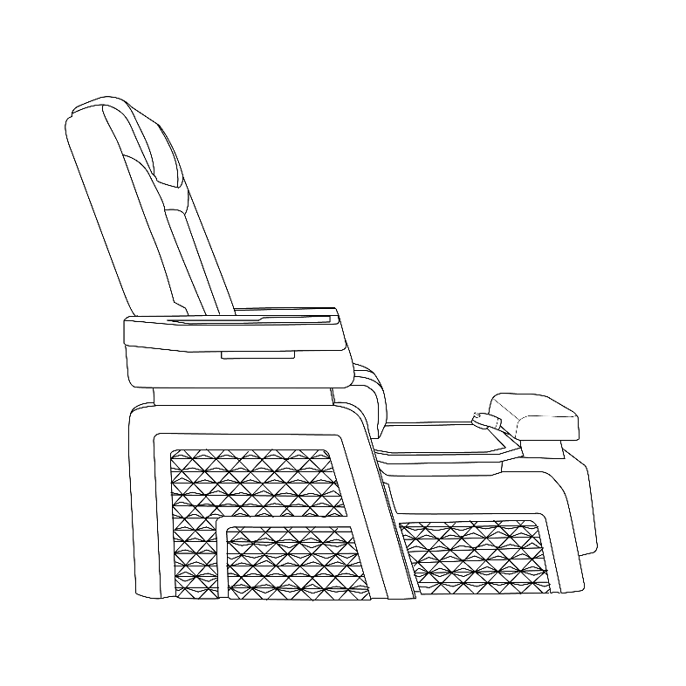
Typical Gravity Sink (Direct Drain) Installation:

2”-3” Gravity Sink
to sewer line
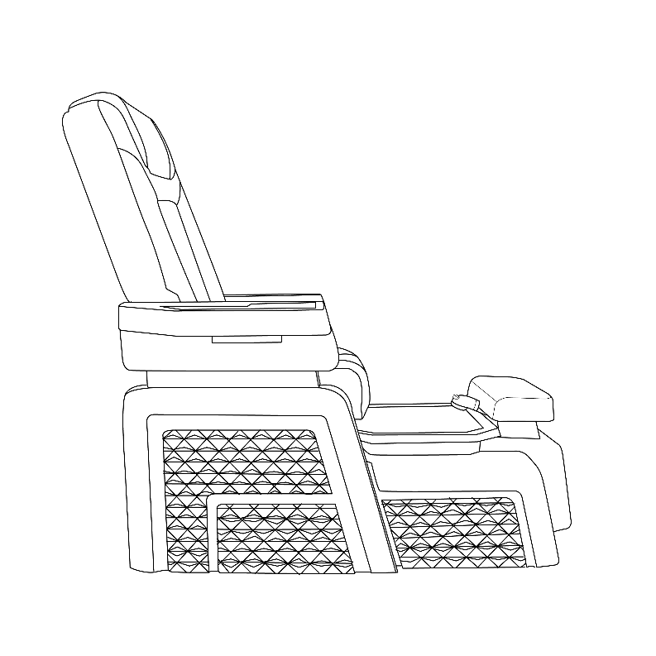
P-Trap 1-1/2” or 1-1/4”

2”-3” Gravity Sink
to sewer line
P-Trap 1-3/4”x1-1/4”
L-Trap 1-1/2” or 1-1/4”

INSTALLATIONS

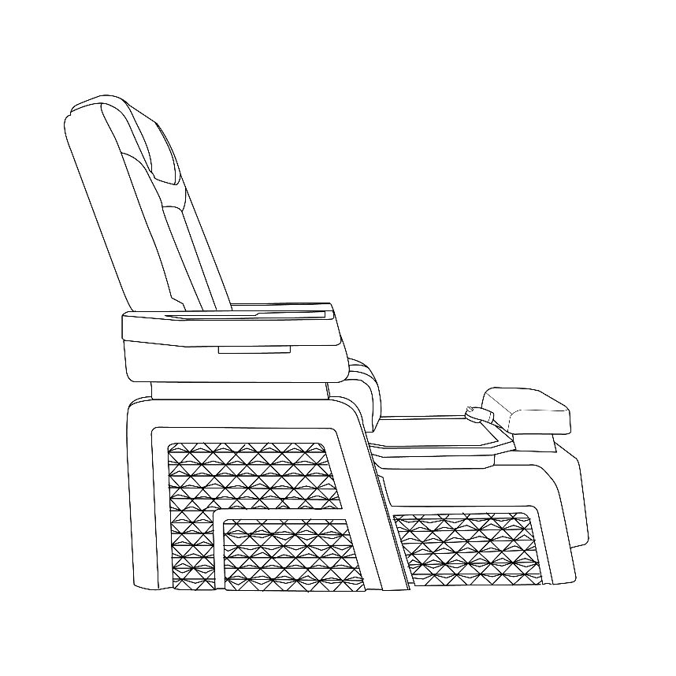
Discharge Pump Installation (OPTIONAL):

Discharge Pump Motor

1 inches Output

Hot and Cold Hoses Installation:

Backflow Valve
supplied by plumber

3/8 inches Output

Hot and Cold Hoses

INSTALLATIONS

Typical Ventilation System Installation (OPTIONAL)

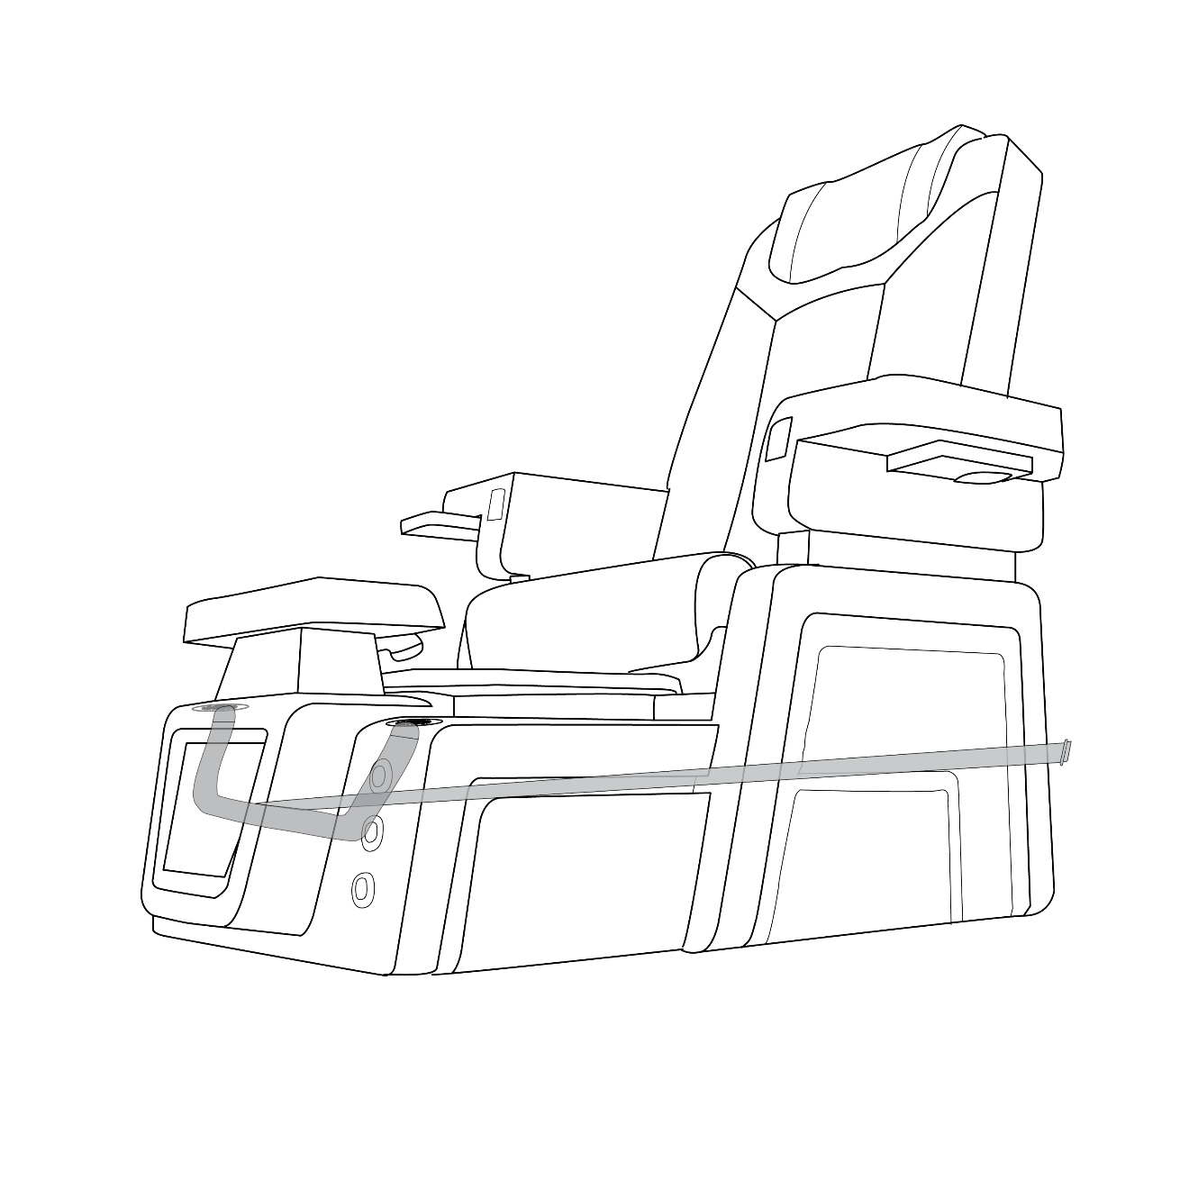

1.5 inches Output
1.5 inches Input

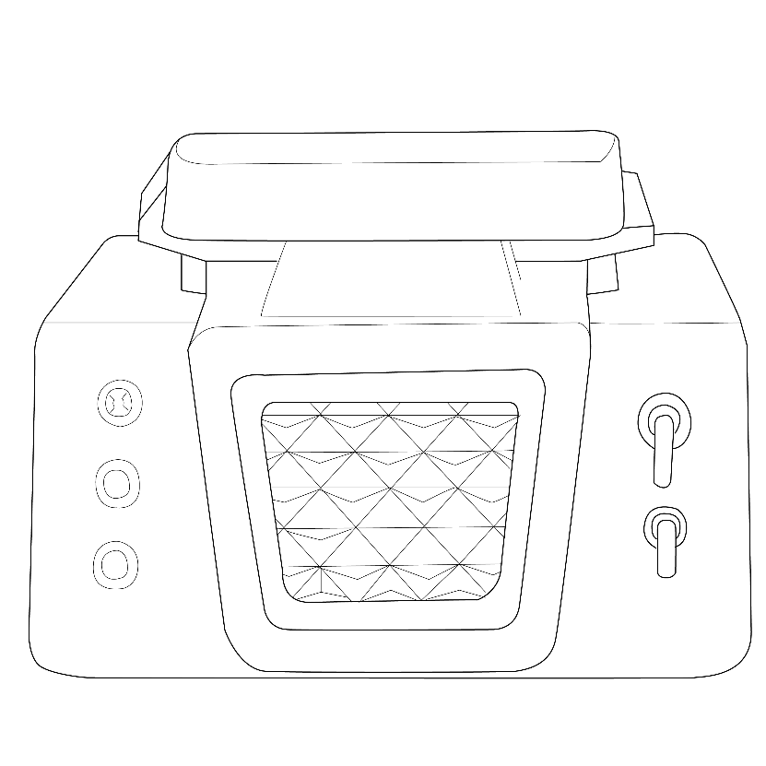
OPERATION & USES

Mixer Knob

Technician Controller

Jet Button
Pump Button
Overflow Knob

- FILLWATER:

The Foot-spa is provided with a single hot and cold mixing valve located in the front of your spa. Lift the handle to start the water flow and adjust to the desired temperature. Let the water fill up the bowl until clean jet body is completely submerged in water.

CAUTION: DO NOT USE FOAMING, SUDSING, OR MINERAL OIL BASED ADDITIVES IN THE WATER.

- START WHIRLPOOL MAGNETIC JET

Press the Jet Button located in the front of your spa. This will start your Whirlpool Magnetic Jet. To stop the whirlpool function, simply press the Jet Button again.

- DRAIN FOOT-SPA BOWL

Turn Drain Knob to popup drain plug/stopper.
- If the spa has gravity drain (discharge pump) system: water in bowl will be empty with duration determined by waste-water plumbing.
- If optional discharge pump system is installed: press Drain/Pump button to activate discharge pump motor. Average drain time approximately one minute (depending on plumbing characteristics).
- MASSAGE CHAIR MANUAL BOOK WILL BE SEND SEPARATELY
OPERATION & USES

BASIC PRECAUTIONS SHOULD ALWAYS BE OBSERVED INCLUDING:
- Read and follow all instructions.
- DANGER. To reduce the risk of injury, DO NOT permit children to use this unit unless they are always supervised.
- Use this unit only for its intended use as described in this manual. DO NOT use attachments that are not recommended by the manufacturer.
- NEVER drop or insert any object into any opening.
- DO NOT block magnetic jet during whirlpool operation.
- The unit must be connected to an electrical supply circuit that is protected by a ground fault circuit interrupter.
- The clean jet motor is magnetically driven and is insulated twice. Therefore, it does not require to be bonded. Save these instructions!

MAINTENANCE & USE

PLEASE REFER THE DIAGRAM TO REMOVE JET COVER FOR CLEANING
T-SPA highly recommends the following cleaning regimen. You should always contact your local governing agency for their specific cleaning and disinfecting requirements and regulations for pedicure spas. For your client’s safety, always use the regulations as a minimum standard for cleaning and disinfecting. Combining your states standards with the regimen listed below will provide your clients with a safe and healthy pedicure spa environment experience.

ROUTINE MAINTENANCE
Powdered cleansers or abrasives are NOT RECOMMENDED. A clean towel or sponge are all that are usually needed. A soft bristled brush may be used when excessive residue is present. Use a mild soap and water solution to clean the upholstery, but DO NOT over wet. Wipe dries with a clean towel. No internal maintenance of the spa components is necessary. Remove clean jet caps and spray with disinfectant after each use. For extra protection, our recommendation is that the system be flushed daily or weekly depending on use. To flush the clean jet system, fill the spa with hot water to just above the jets. Add disinfectant. Run whirlpool for 15 minutes, drain and then wipe dry with clean, soft cloth.

NOTE:
The use of oil-based products can build up in the whirlpool system, causing clogging in the jets. Adherence to the above cleaning will minimize build up. T-SPA DO NOT recommend the use of mineral oil-based products.
Cleaning or sanitizing is NOT disinfecting. According to the Centers of Disease Control and Prevention (CDC), and the US Environmental Protection Agency (EPA), disinfecting occurs only when there is a reduction of pathogenic microbes at 99.999%. Sanitizing is only a reduction of 99.9%. Cleaning of whirlpool pedicure spa requires surfactant and chelating detergents that are low-foaming and can remove body oils, organic oil additives, mineral oil, skin cells, nail clippings etc. that can accumulate both in the basin and the jets which may become a fertile area for microorganism to grow.

MAINTENANCE & USE

TESTING/FLUSING FOOT-SPA
After the foot spa has been installed, fill tub with water just above the jets. Carefully check for leaks at the drain and motor mount. After checking underside for leaks, turn on whirlpool system by pushing Jet button and watch for leaks as water circulates. Let the tub run on full cycle. Open drain plug to discharge

WARRANTY & SERVICE

T-SPA warrants to the original purchaser that the new pedicure spa will be free from defect during the Standard Warranty Period (listed below). The shipping date and the uniquely coded Serial Number on the back of each spa chair will justify the start of the warranty period for the product. The warranty is null and void if the pedicure spa has been taken from its initial place of installation, or it is not installed in accordance with federal, state, or local codes and ordinances. Also, this warranty does not apply if the pedicure spa has been subject to misapplication, improper installation or maintenance, negligence, improper cleaning, or other circumstances beyond T-SPA's control.

WARRANTY
- Limited Two (2) years Parts and Labor for the fiberglass on the spa shell.
- Limited One (1) year Parts and Labor for the Gel on the spa shell.
- Limited One (1) year Parts for the paint on the spa shell.
- Limited One (1) year Parts for the resin sink and fiberglass sink.
- Limited warranty based on shipment for the glass sink.
- Limited One (1) year Parts for hydraulic system and electrical components.
- Limited One (1) year Parts and Labor for the Whirlpool Pump, Clean Jet and Magnetic Jet.
This limited warranty shall be in full force and effect for any Buyer’s experiencing workmanship, mechanical, installation, or composition failures so long as the purchased goods are correctly installed and used in accordance with official installation and maintenance instructions.

EXCLUSION

- Damage to pump parts and/or motor parts due to obstruction in plumbing lines.
- Staining, fading or discoloration of plastic surfaces due to exposure and/or the use of harmful cleaning agents or chemicals.
- Staining, fading or discoloration of the seat, armrest, or footrest.
- Staining, fading, or discoloration caused by improper or poor water additives not related to the maintenance of proper water are not covered by this warranty.
- Freight damage, misuse, neglect, accident, natural disaster, and abuse.
- Unauthorized repairs.

WARRANTY & SERVICE

SERVICE
- The dealer shall forward all warranty-related matters to our Customer Service Department.
- Serial Numbers and Original Invoice must accompany all warranty claims.
- Customers are responsible for shipping defective parts back to T-SPA. These parts must be packaged correctly to protect against any further damage.
- All parts are to be shipped by Ground services, average of 2-5 days.
- All defective parts must be shipped back to T-SPA within 30 days of receiving the new replacement parts or warranty will be void.
- Any warranty claim that cannot be determined over the phone call, the customer must send photos to T-SPA for inspection related.
- Any service performed on the product without T-SPA authorization will also void the warranty.
- Each Service call from the customer will be assigned a Claim Number. The Claim Number will stay open until the problem is resolved.

No dealer or other person has any authority to bind T-SPA to changes or additions to this warranty or its products. accordingly, T-SPA is not responsible for such warranties or representations.

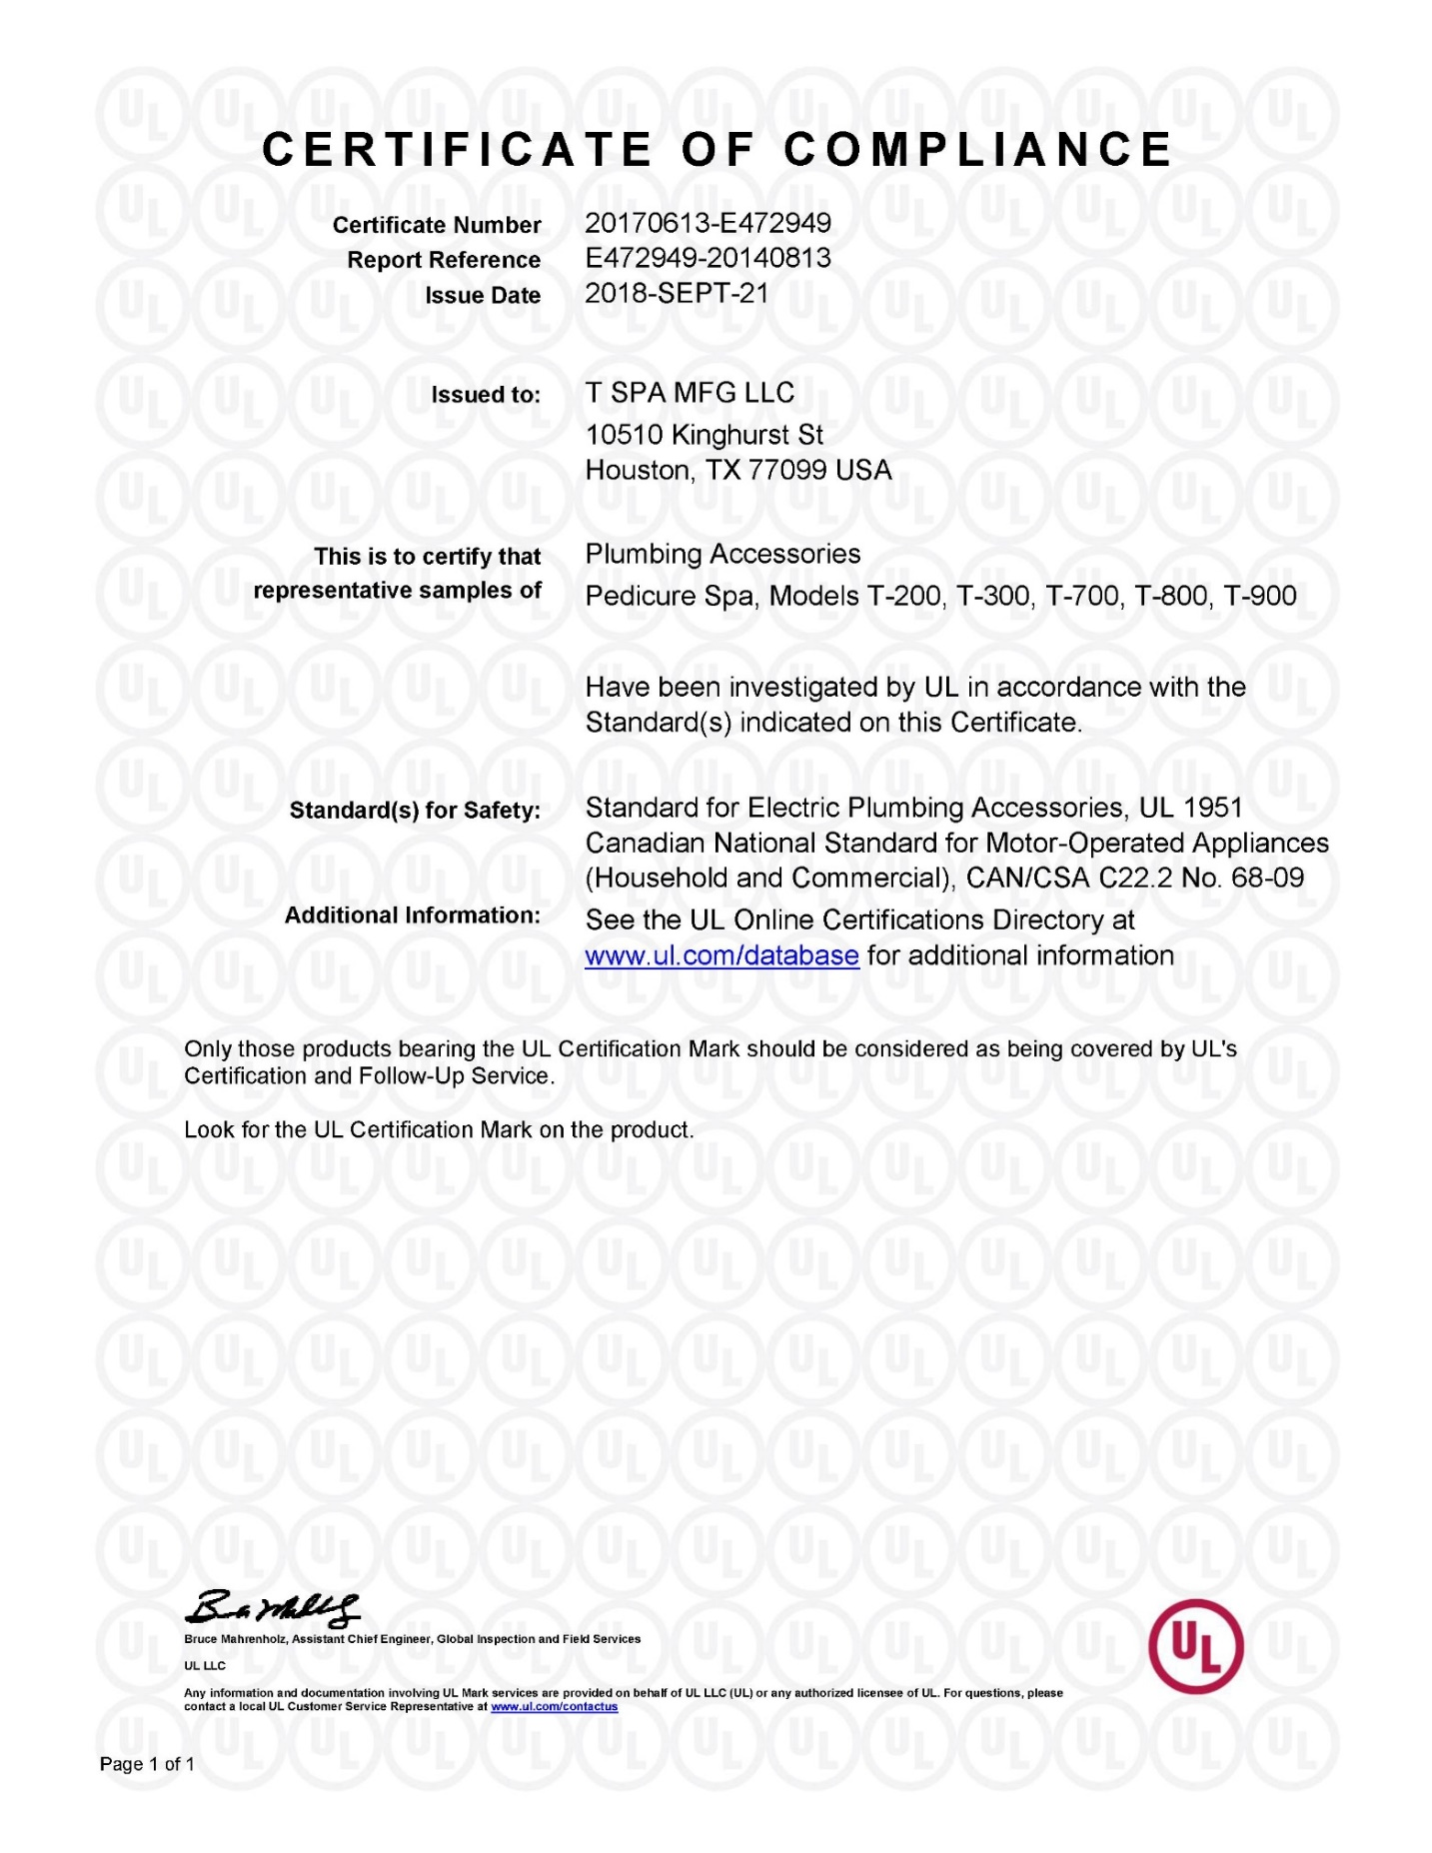
LIMITED WARRANTY REGISTRATION FORM

IMPORTANT

To validate the limited warranty, Limited Warranty Registration Form MUST be filled out completely and return to T-SPA within 30 days of original purchased date. This Limited Warranty is valid if T-SPA received the registration form from the original purchaser.

FULL NAME: ……………………………………………………………………………………………….

EMAIL ADDRESS: ………………………………………………………………………………………...

SALON NAME: …………………………………………………………………………………………….

SALON ADDRESS: …………………………………………………………………………………........

SECOND ADDRESS (Suite, Unit): ………………………………………………………………………

CITY: …………………………………………………… STATE: …………. ZIP CODE: ……………..

DISTRIBUTOR (if any): …………………………………………………………………………………...

DISTRIBUTOR ADDRESS: ………………………………………………………………………………

CITY: ……………………………………………………… STATE: ………. ZIP CODE: …………….

VERSION: T-…………………… MODEL: …………………………………………… Pedicure Chair

INVOICE NO.: ……………………………………………………………………………………………..

DATE OF PURCHASE: …………………………………………………………………………...……...

Completed Warranty Registration Form Send To:

T-SPA MFG, LLC
10510 KINGHURST
HOUSTON, TX 77099
FAX: (832) 230-5486
EMAIL: info@tspallc.com

